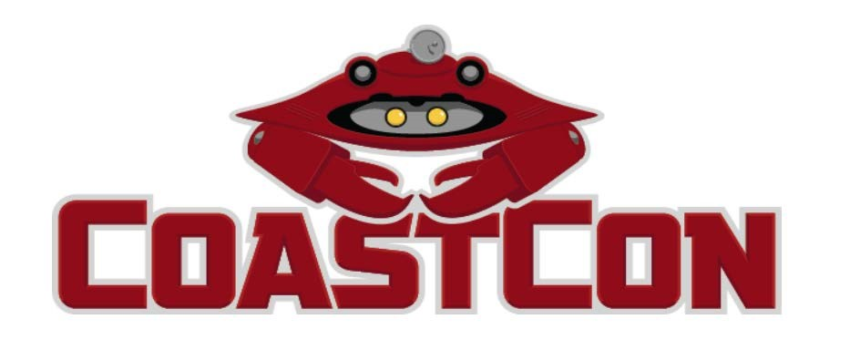

**Dear Artist,**

**Thank you for your interest in the CoastCon Art Show and Auction. CoastCon is a three-day, fan-run, general science fiction convention with a literary focus held annually in Biloxi, MS. It is dedicated to the genres of science fiction, fantasy, comics, gaming, and anime/manga. CoastCon has the honor of being the longest running convention of its type on the Gulf Coast and is one of the larger events in our region, attracting members from across the South. CoastCon has also had the honor of working with some of the best and the brightest artists in the nation- artists like you. I’d like to ask if you would be interested in being a part of our next CoastCon Art show and Sale.**

**The 2025 CoastCon Art Show features three-dimensional and two-dimensional art in a variety of media within the themes of science fiction, fantasy, comics, gaming, or anime/manga. The show consists of art for viewing or purchase throughout the weekend and an auction on Sunday afternoon. We also provide space for a “Print Shop” to allow for sales of unframed or duplicates of hanging works and sculpture in all media. As a side note, CoastCon also offers a limited number of artist alley tables for artists attending. If you are interested in purchasing an artist alley table, please contact us as soon as possible.**

**You will find the rules and registration form for the Show/Auction/Print Shop attached below. The Art show control sheets and bid sheets are available on the CoastCon website. By signing the rules and control sheet, you agree to the rules as presented. Please fill out these sheets as completely as possible so that we may keep track of your work and sales. As space is limited, we must receive your control sheet/registration form and payment by February 28, 2025, to reserve/guarantee your spot. Mailed artwork must be received by February 28, 2025. You may also deliver your work to the convention site in person on Friday, March 7, 2025, between 9:00 am and 1 pm if you have already registered or otherwise contacted us about participating. Space is limited and is available on a first-come, first served basis.**  **Please contact me if you have any questions.**

**Thank you,**

**Frank Schiavo**

**Art Show / CoastCon 2025 cccfranks@yahoo.com**

**504-484-1096/504-289-6240**

# CoastCon Art Show/Auction & Print Shop Submission Guidelines

CoastCon is a Science/Science Fiction/Fantasy oriented convention, so please keep this in mind when sending your work. If you think it fits our theme, send it in! We welcome both 2D and 3D art.

There is a $0.50 per piece hanging fee for art entered in the art show. A name card can be placed with your work at no cost. Be prepared to share panels/tables with other artists. All art should be prepared for display. There is no limit to the amount of art you can enter in the art show. Hanging space will be available on a first-come, first-serve basis. Walk-in artists are accepted and encouraged but please contact us to reserve your space. Table space for three-dimensional pieces is available on request. CoastCon receives a 15% commission on all art sold through the art show, auction, and print shop. Checks will be mailed to the artists (or their agents if so requested) within three weeks of the convention end date.

There will be a print shop for prints and reproductions submitted by artists. There is no hanging fee for print shop items, only for art displayed in the art show. Print shop items are sold through direct sale, not by bid. We are happy to display a copy of a limited-edition print in the art show to promote further copies on display in our print shop. Please clearly describe this promotional method on the art show and print shop control sheets. An original may also be hung in the art show marked “Not for Sale” and prints included in the print shop. Again, just let us know.

**Send Mail-in art to: CoastCon Art Show c/o: Frank Schiavo**

**114 Barbara Circle**

**Ocean Springs, MS 39564**

All packages must be clearly marked as artwork for the CoastCon Art Show. Ship all mail-in art in sturdy, reusable shipping containers. Art not sold at the convention may be picked up on Sunday of the convention for attending artists/guests. Mail-in art will be sent back within three weeks after CoastCon (If possible, United Parcel Service (UPS) will be used to return art - it is automatically insured for $100, and the package is traceable.) In instance were payment for hanging fees, postage, and any shipping insurance the artist may request isn’t provided by the artist or covered by sales, CoastCon will contact the artist for other arrangements. Permission to use copyrighted characters, when required, is the responsibility of the artist. We will cooperate with legitimate efforts to enforce copyrights. CoastCon staff provides security while the art show is open, and the show is closed/locked after hours.

All art sold at CoastCon is subject to Mississippi state sales tax and CoastCon will collect Mississippi sales tax (7% of sales) as required by law on all sales. Please keep that in mind when pricing your items. CoastCon does host an after-auction Minimum bid sale for unsold art on Sunday for participating artists. Please let the Art Show staff know if you wish to participate in this sale or not by checking the appropriate line below. If you have questions not answered by the information above, please contact us at cccfranks@yahoo.com. Thank you for reading these Artist Guidelines. We hope you have a good convention and sell everything you submit!

**I have read and agree with the guidelines above:**

**Names: _________________________________________________________ Date: ________**

**I wish to be a participant in the After-Auction/Minimum Bid sale. YES_ __ NO___**